**Personal Portfolio**

Group: 15

Michael Bell – n9487921

<https://bitbucket.org/ifb299group15/>

**Artifact 1** – Automated Testing (Selenium)

**Description of the Artifact:**

One of my major contributions to sprint two has been the development of an automated testing system. I developed these automated tests using the Selenium chrome extension. Each of these tests automatically runs through different sections of the website and ensures it is functionality. Tests are performed on both cosmetic (e.g. ensuring a page/element is showing) and functional areas of the website (e.g. ensuring a user can register).

**Contribution to Project:**

Previously our team has been testing the website manually with the aid of an excel spreadsheet I developed in sprint one. This form of testing proved to be quite tedious to complete every time a new feature was implemented. Having an automated testing system has significantly improved our teams productivity and when testing the website, and my team has been very appreciative of this system.

**Implementation:**

Figure 1 show a screenshot from the Selenium chrome extension where automated test cases for the music school website were created. The test case selected in the figure shows an example which tests to see if a new user is able to register. It automatically navigates through the website and fills out the registration form and checks to see if it submits successfully. JavaScript was used to automatically generate a new username each time the test is run.

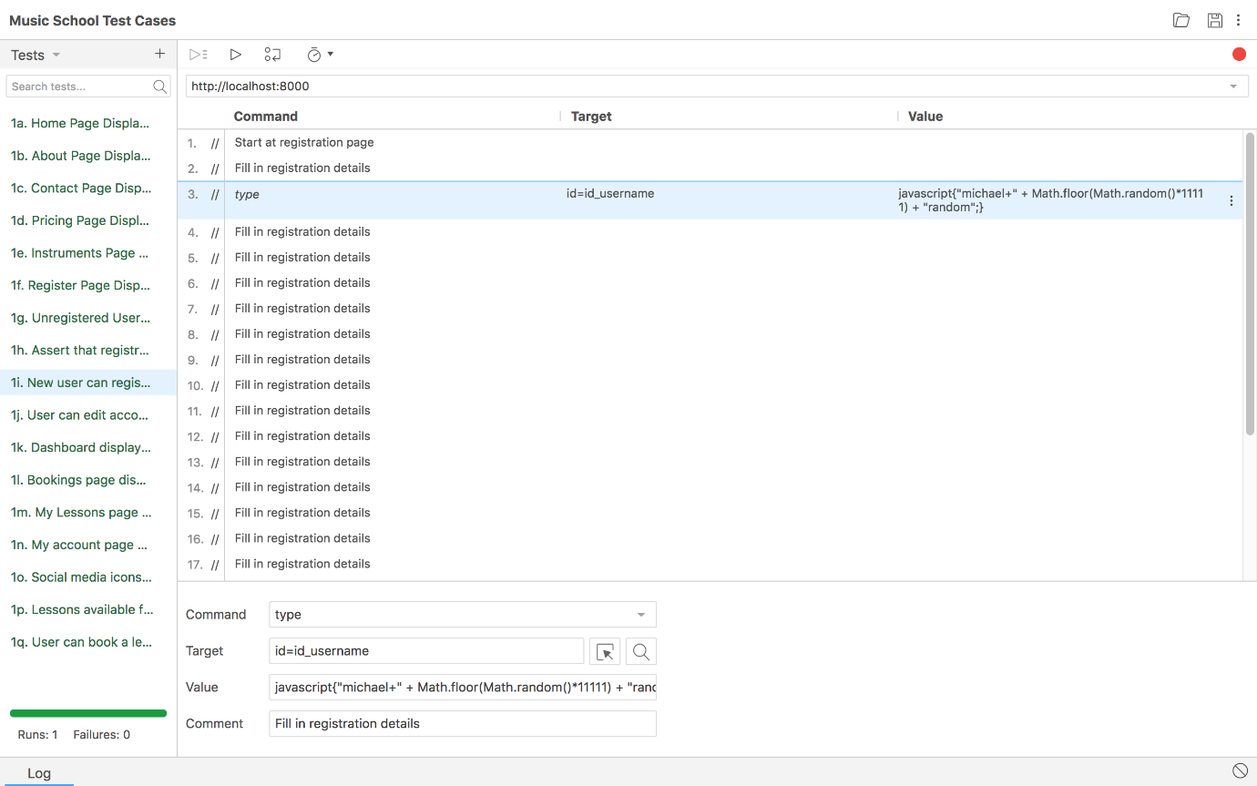

Figure 1 - Selenium Chrome Extension

Various tests of this form were completed on a range of website functions which allowed our team to streamline our testing process and quickly isolate issues. A full copy of the selenium tests can be found in the relevant artifact folder.

**Artifact 2** – Revised Data Flow Diagrams

**Description of the Artifact:**

A data flow diagram is a visual representation of the flow of data through a system. In terms of the music school website, there are three main streams of dynamic data. These are contained in the account creation, lesson bookings, and instrument hire. Data flow diagrams were created during sprint one however as the systems have undergone a lot of significant design changes, it was necessary to revise the current data flow diagrams.

**Contribution to Project:**

By revising the previous data flow diagrams our group was able to have a greater understanding of how the all the systems interacted in their current form. This visual representation allowed for all team members to quickly educate themselves on how our database tables and web pages were interacting with the user.

**Implementation:**

The notation used for the data flow diagrams was loosely based on the *Yourdon and Coad* notation. Blue boxes represent a user, pink circles represent a process, yellow boxes represent a data store, and the arrows show the flow of data.

Figure 2presents a data flow diagram for the music schools current lesson booking system. It shows the users interaction with the front end and back end components of the website.

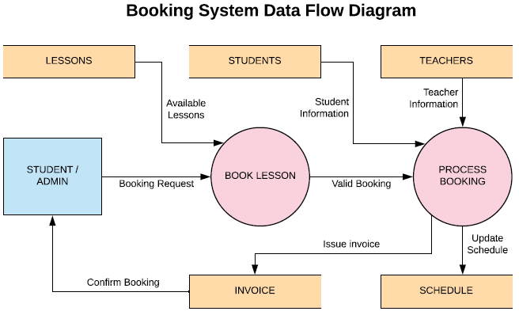

Figure 2 - Booking System Data Flow Diagram

Figure 3 presents a data flow diagram for the instrument hire process. It can be seen that this data flow diagram is very similar to the booking system data flow diagram.

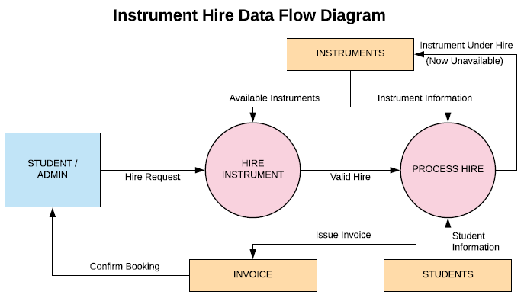

Figure 3 - Instrument Hire Data Flow Diagram

Figure 4 presents a dataflow diagram for the account creation system of the website. It shows the transition from an unregistered user to a registered user.

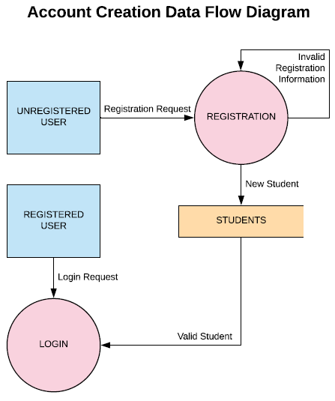

Figure 4 - Account Creation Data Flow Diagram

**Artifact 3** – Revised Site Map

**Description of the Artifact:**

A site map provides a visual representation on how a user can navigate to different pages on a website. It is also a useful tool for providing a quick overview of all the different pages on the website. Due to various design changes, the site map created during sprint one is no longer an accurate representation of the current website; thus it was decided that a revised version was necessary.

**Contribution to Project:**

A revised sitemap allowed the team to quickly view an overview of our website and present this information to the client. Through creating the sitemap we noticed some potential areas for simplification and combined some pages into one. An example of this was merging the teacher contact information page onto the dashboard page which decluttered the navigation bar of the website.

**Implementation:**

Figure 5 shows the site map of the current form of the website. Related pages are grouped under the same colour scheme.

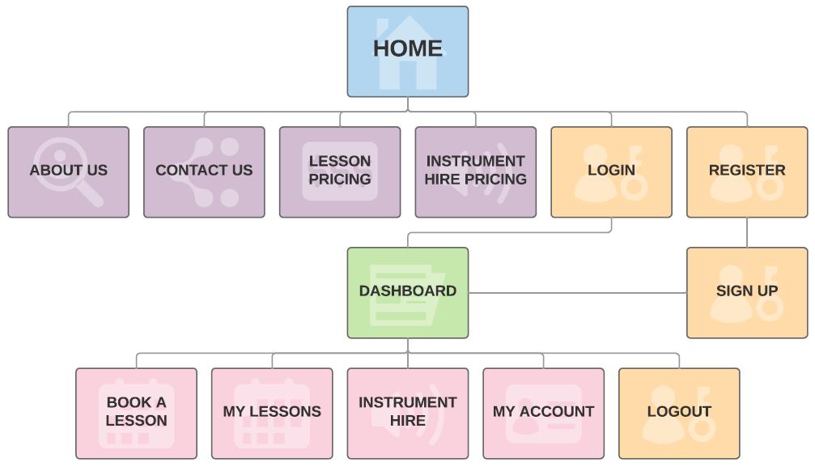

Figure 5 - Pinelands Music School Site Map

**Artifact 4** – Website Page Revisions and Additions

**Description of the Artifact:**

During sprint two I was heavily involved in the redevelopment of several website pages. Whilst almost all website pages were changed in some way, the home page and dashboard page were redeveloped significantly.

**Contribution to Project:**

The redevelopment of these pages was done at the request of the client. Through updating these pages I provided a product that our team was able to present to the client. The major requests from the client was to include an easily customisable testimonials section on the home page, and to include teacher contact information on the dashboard page. Several other changes were made to the dashboard to ensure the upcoming lessons section was communicating with the database.

**Implementation:**

Figure 6shows the current form of the home page and the added testimonials section.

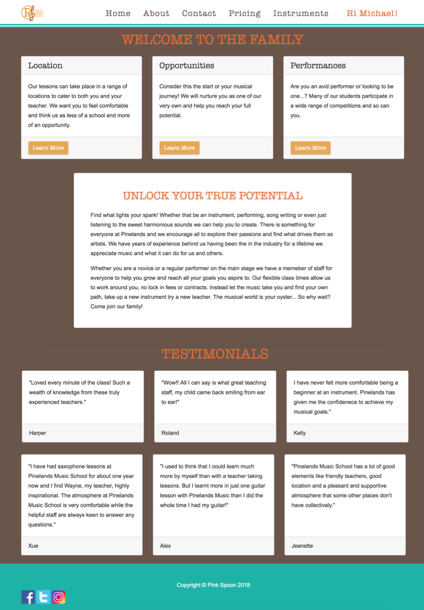

Figure 6 - Screenshot of Home Page

Figure 7 shows the current form of the dashboard page and the added teacher contact information section. It can also be seen that the upcoming lessons section is communicating with the database and correctly displaying the student’s upcoming lessons.

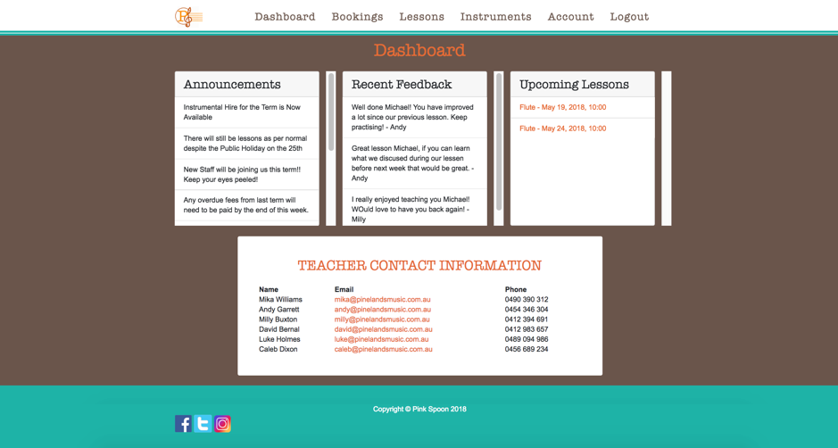

Figure 7 - Screenshot of Dashboard Page

**Artifact 5** – Storyboarding

**Description of the Artifact:**

A storyboard provides a visual representation of how a typical user may interact with the website**.** This is done through annotated drawings which show the lifecycle of a user discovering the website, to regularly using it.It does not exhaust every possible interaction with the website.Whilst normally done before development, creating a storyboard during development allows the team to ensure they haven’t lost sight of the bigger picture and the current product is meeting the core functionality that it should.

**Contribution to Project:**

Taking a step back from development and creating a storyboard allowed our team to ensure we hadn’t lost sight of the bigger picture. It allowed us to put ourselves in the shoes of a student and think about how a typical user would interact with the website from the beginning. By doing this we could ensure that the current form of the website was simple to use and the main required features were working correctly.

**Implementation:**

I first developed the story boards with pen and paper then transitioned to a software to create a high fidelity storyboard. The full story boards can be found in the relevant artifact folder. A screenshot from the first page of stories and the transition from low fidelity to high fidelity can be seen in Figure 8. I went through this storyboard with the entire team and we were happy with the simplicity of our website and its ability to meet core functionality.

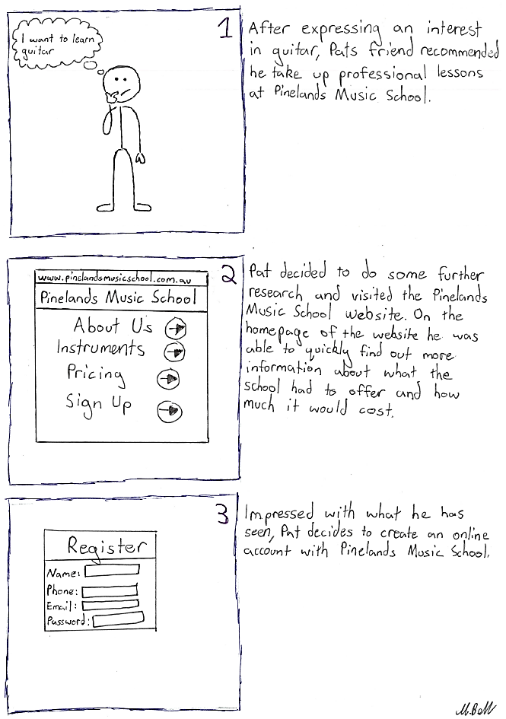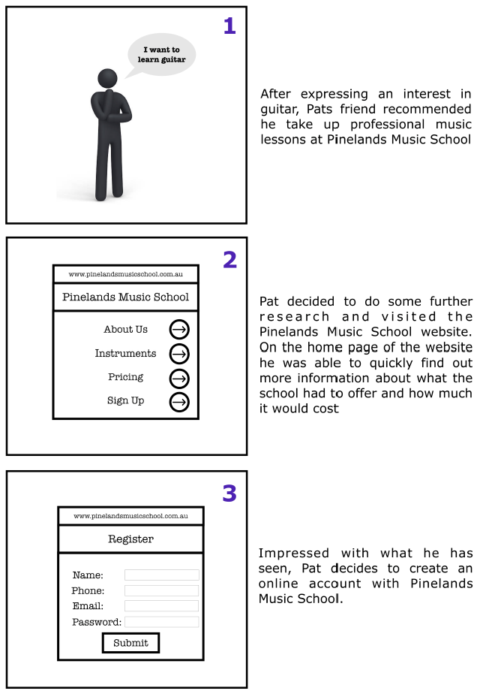

Low Fidelity →→→ High Fidelity

Figure 8 - Extract from storyboards. Transition from low fidelity to high fidelity. See artifact folder for full storyboards